Fagus Sylvatica glmulti.analysis
After 50 models:
Best model: RespCorrectedWeight_GrCO2_KGr_Year~1+DiamClass+Class+T3+DensityKgM3
Crit= 11461.7137446509
Mean crit= 11726.5904208398
Completed.

Method: h / Fitting: rma.glmulti / IC used: aicc
Level: 1 / Marginality: FALSE
From 32 models:
Best IC: 11461.7137446509
Best model:
[1] "RespCorrectedWeight_GrCO2_KGr_Year ~ 1 + DiamClass + Class + "
[2] " T3 + DensityKgM3"
Evidence weight: 0.598320894069197
Worst IC: 12008.5073455457
2 models within 2 IC units.
2 models to reach 95% of evidence weight.

MODEL
1 RespCorrectedWeight_GrCO2_KGr_Year ~ 1 + DiamClass + Class + T3 + DensityKgM3
2 RespCorrectedWeight_GrCO2_KGr_Year ~ 1 + DiamClass + Class + T3 + Soil_moist + DensityKgM3
aicc weights
1 11461.71 0.5983209
2 11463.06 0.3054325
> summary(res@objects[[1]])

Mixed-Effects Model (k = 1394; tau^2 estimator: ML)

logLik deviance AIC BIC AICc ​
-5724.8266 11449.6532 11461.6532 11493.0928 11461.7137

tau^2 (estimated amount of residual heterogeneity): 115.6979 (SE = 4.6763)
tau (square root of estimated tau^2 value): 10.7563
R^2 (amount of heterogeneity accounted for): 44.06%
Test of Moderators (coefficients 2:5):
QM(df = 4) = 667.2427, p-val < .0001

Model Results:

estimate se zval pval ci.lb ci.ub ​
intrcpt -0.4913 2.2143 -0.2219 0.8244 -4.8313 3.8487
DiamClass 0.4830 0.0359 13.4559 <.0001 0.4126 0.5533 ***
Class 0.7726 0.3040 2.5415 0.0110 0.1768 1.3685 *
T3 0.7143 0.0372 19.2070 <.0001 0.6414 0.7871 ***
DensityKgM3 -0.0102 0.0026 -3.8343 0.0001 -0.0153 -0.0050 ***

---
Signif. codes: 0 ‘***’ 0.001 ‘**’ 0.01 ‘*’ 0.05 ‘.’ 0.1 ‘ ’ 1

Model Results:

estimate se zval pval ci.lb ci.ub ​
intrcpt 1.0470 2.8941 0.3618 0.7175 -4.6253 6.7193
DiamClass 0.4853 0.0360 13.4877 <.0001 0.4148 0.5558 ***
Class 0.7887 0.3042 2.5922 0.0095 0.1924 1.3850 **
T3 0.7071 0.0381 18.5765 <.0001 0.6325 0.7817 ***
Soil_moist -0.0007 0.0009 -0.8235 0.4102 -0.0024 0.0010
DensityKgM3 -0.0098 0.0027 -3.6879 0.0002 -0.0151 -0.0046 ***
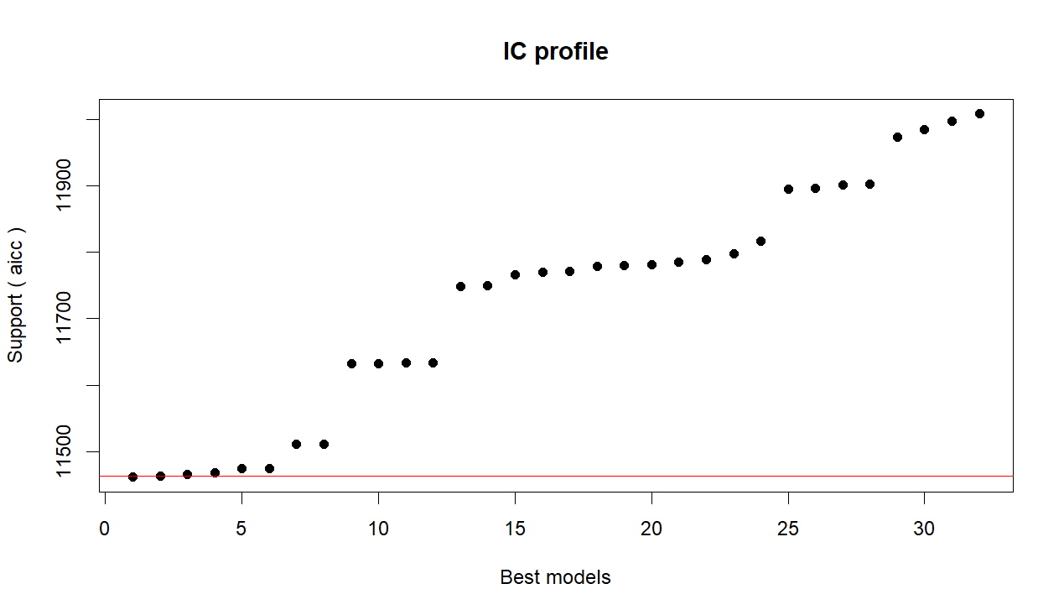
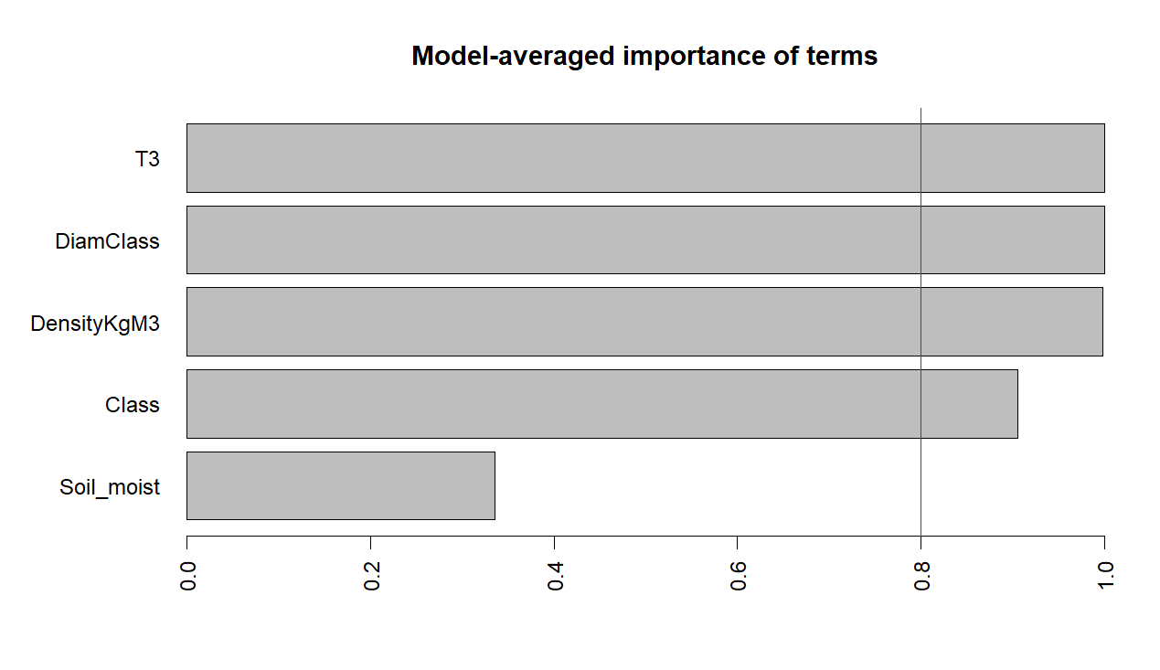
Unconditional values
Estimate Std. Error z value Pr(>|z|) ci.lb ci.ub Importance
intrcpt 0.4131 2.7491 0.1503 0.8806 -4.9751 5.8013 1.0000
DiamClass 0.4813 0.0367 13.1037 0.0000 0.4093 0.5532 1.0000
T3 0.7119 0.0376 18.9165 0.0000 0.6382 0.7857 1.0000
DensityKgM3 -0.0104 0.0029 -3.6447 0.0003 -0.0160 -0.0048 0.9980
Class 0.7062 0.3507 2.0138 0.0440 0.0189 1.3935 0.9058
Soil_moist -0.0002 0.0005 -0.4834 0.6288 -0.0012 0.0007 0.3356
Abies alba
After 50 models:
Best model: RespCorrectedWeight_GrCO2_KGr_Year~1+DiamClass+Class+T3+Soil_moist+DensityKgM3
Crit= 10792.1184419189
Mean crit= 11031.2382617163
Completed.
glmulti.analysis
Method: h / Fitting: rma.glmulti / IC used: aicc
Level: 1 / Marginality: FALSE
From 32 models:
Best IC: 10792.1184419189
Best model:
[1] "RespCorrectedWeight_GrCO2_KGr_Year ~ 1 + DiamClass + Class + "
[2] " T3 + Soil_moist + DensityKgM3"
Evidence weight: 0.741730795629566
Worst IC: 11290.3862250759
1 models within 2 IC units.
1 models to reach 95% of evidence weight.

1 RespCorrectedWeight_GrCO2_KGr_Year ~ 1 + DiamClass + Class + T3 + Soil_moist + DensityKgM3
aicc weights
1 10792.12 0.7417308

Mixed-Effects Model (k = 1283; tau^2 estimator: ML)

logLik deviance AIC BIC AICc ​
-5389.0153 10778.0306 10792.0306 10828.1293 10792.1184

tau^2 (estimated amount of residual heterogeneity): 137.2581 (SE = 5.6766)
tau (square root of estimated tau^2 value): 11.7157
R^2 (amount of heterogeneity accounted for): 45.56%

Test of Moderators (coefficients 2:6):
QM(df = 5) = 615.7353, p-val < .0001

Model Results:

estimate se zval pval ci.lb ci.ub ​
intrcpt -2.8101 3.2178 -0.8733 0.3825 -9.1170 3.4967
DiamClass 0.7788 0.0446 17.4776 <.0001 0.6915 0.8661 ***
Class 1.4812 0.3044 4.8666 <.0001 0.8847 2.0778 ***
T3 0.5359 0.0431 12.4275 <.0001 0.4514 0.6204 ***
Soil_moist -0.0043 0.0010 -4.3463 <.0001 -0.0062 -0.0023 ***
DensityKgM3 0.0059 0.0029 2.0353 0.0418 0.0002 0.0116 *

---
Signif. codes: 0 ‘***’ 0.001 ‘**’ 0.01 ‘*’ 0.05 ‘.’ 0.1 ‘ ’ 1
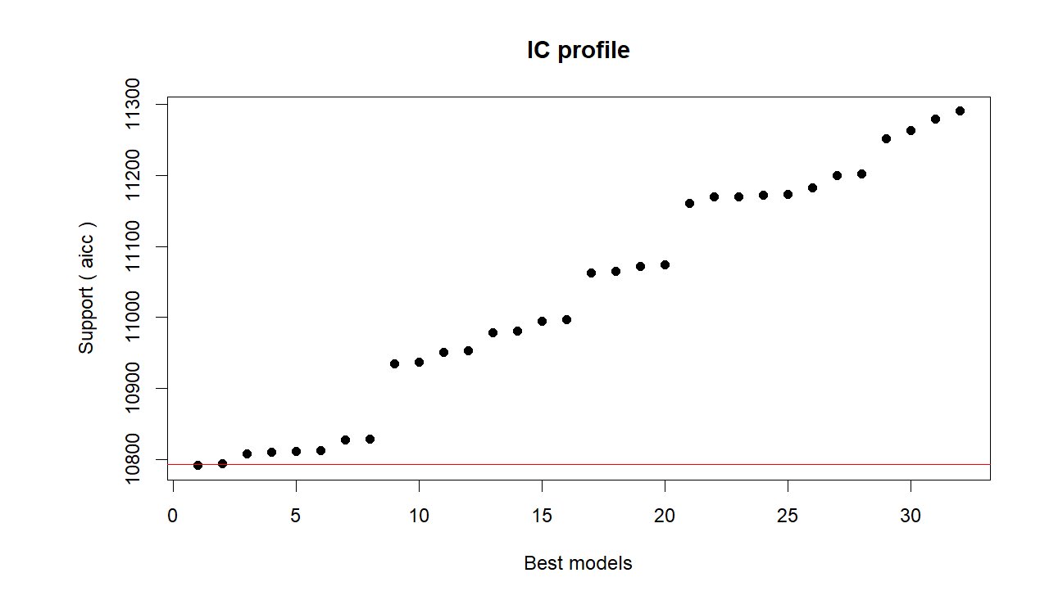
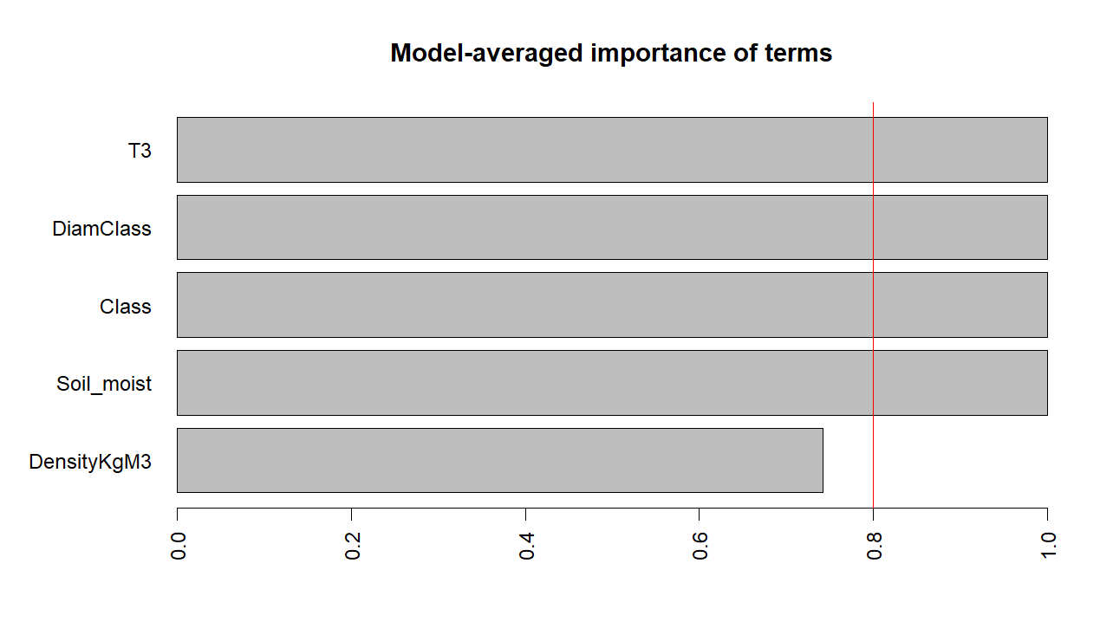
Estimate Std. Error z value Pr(>|z|) ci.lb ci.ub Importance
intrcpt -1.8030 3.5080 -0.5140 0.6073 -8.6785 5.0725 1.0000
DiamClass 0.7646 0.0486 15.7255 0.0000 0.6693 0.8599 1.0000
T3 0.5366 0.0432 12.4299 0.0000 0.4520 0.6212 1.0000
Class 1.4089 0.3205 4.3957 0.0000 0.7807 2.0371 0.9999
Soil_moist -0.0043 0.0010 -4.3233 0.0000 -0.0062 -0.0023 0.9998
DensityKgM3 0.0044 0.0036 1.2298 0.2188 -0.0026 0.0114 0.7419

